**Advanced Systems Project**

**Hospital Management System using MERN Stack**

**Technologies used:** Mongo DB, Express.js, React.js, Node.js. Bootstrap (front-end framework) and Redux (JavaScript library).

**Some Key Features:**

1. Notification to user
2. Patient History
3. Slot opened up
4. Doctor – ability to cancel with notes
5. Update appointment
6. Checkout
7. Notes for doctor
8. Billing at the end of checkout with discount for insurance
9. No two appointments on the same day for one specialty

**Use Case Diagram**

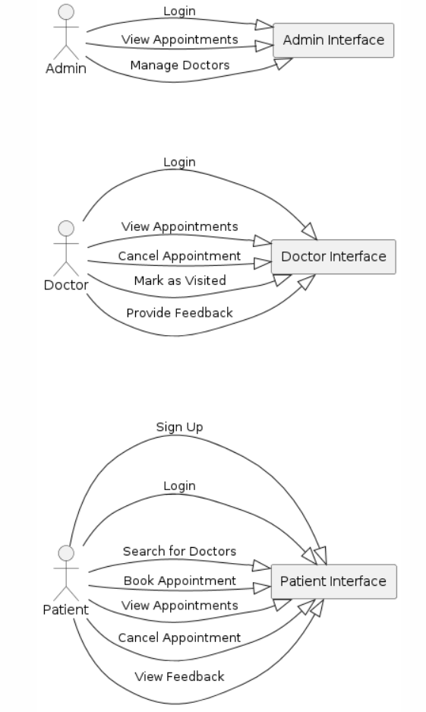

**Class Diagram**

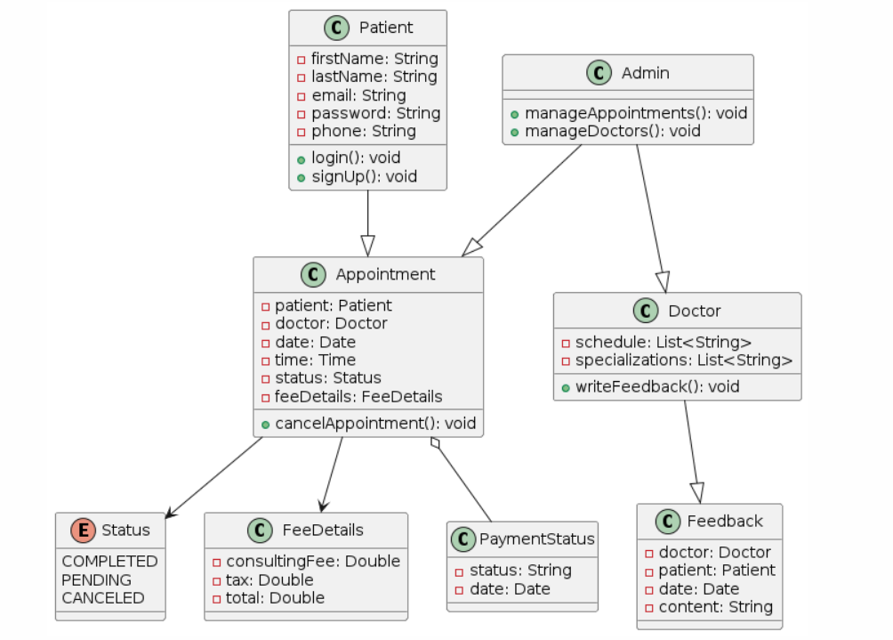

**Sequence** **Diagram**

